Forms and Validations in Angular

## Template Driven Forms:

1. Template driven forms are suitable for development of simple forms with limited number of fields and simple validations
2. In this forms, each field is represented as a property in the component class
3. Validation rules are defined in the template, using “html5” attributes. Validation messages are displayed using “Validation Properties” of angular
4. “FormsModule” should be imported from “@angular/forms” package

## HTML 5 attributes for Validations:

1. required = “required” -- Field is mandatory
2. minlength =”n” -- Minimum number of characters
3. Pattern = “regEx” -- Regular Expression

## Validation Properties:

1. Untouched
   1. true -- Field is not focused
   2. False -- Field is focused
2. Touched
   1. True -- Field is focused
   2. False -- Field is not focused
3. Pristine
   1. True -- Field is not modified by the user
   2. False -- Field is modified by the user
4. Dirty
   1. True -- Field is modified by the user
   2. False -- Field is not modified by the user
5. Valid
   1. True -- Field value is valid
   2. False -- Field value is invalid
6. Invalid
   1. True -- Field value is invalid
   2. False -- Field value is valid
7. Errors -- Represents the list of errors of the field
   1. Required -- true/false
   2. Minlength -- true/false
   3. Pattern -- true/false
   4. Number -- true/false
   5. Email -- true/false
   6. Url -- true/false

## Template Driven Forms - Example

Fields:

* Firstname
* Lastname
* Email
* Account
* Gender
* Country

Step 1: Create a new angular application and open it on Visual studio

Step 2:

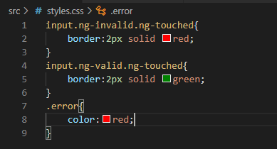

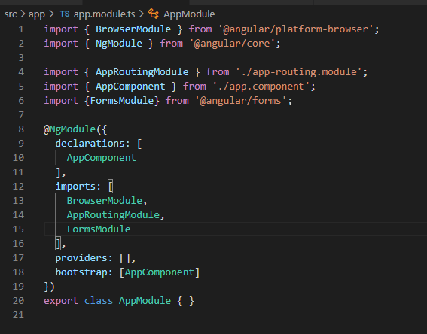

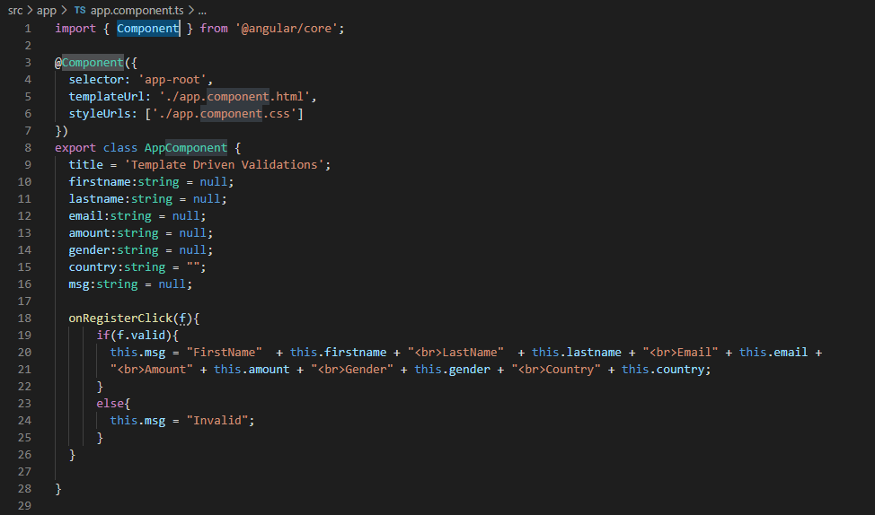

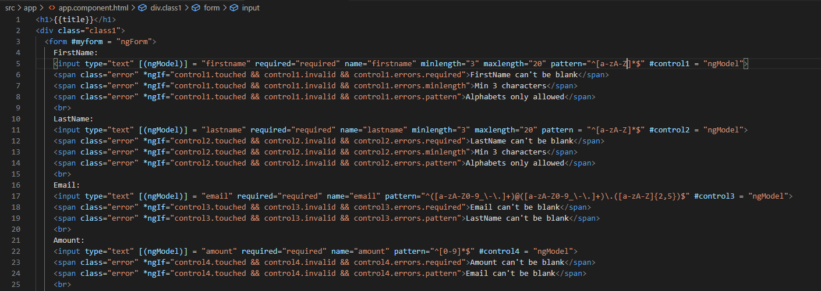

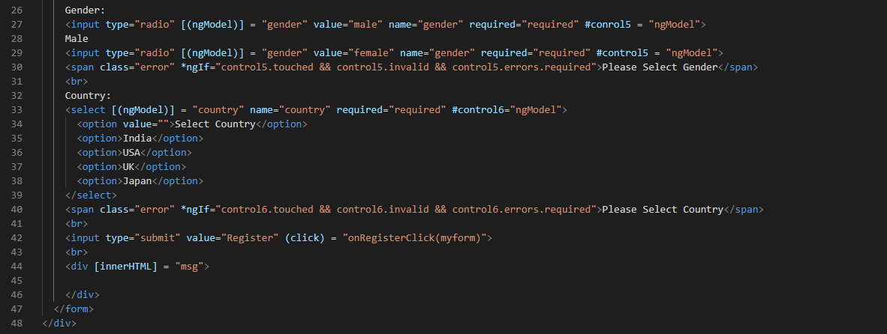

Open the terminal and type as ng serve. After look at the port number 4200 on your browser

## Reactive Forms or Model Driven Forms

* Reactive Forms or Model Driven Forms are new type of in angular which are suitable for creating large forms with many fields and complex validations
* In these forms each field is represented as “FormControl” and group of controls is represented as “FormGroup”
* “ReactiveFormsModule” should need to imported from “@angular/forms” package
* Validation rules are defined in the component using “Validators” object of angular and validation messages are displayed in the template using “Validation Properties” of angular

## Validations in Reactive Forms:

* Validators.required -- Field is mandatory
* Validators.minLength -- Minimum number of characters
* Validators.maxLength -- Maximum number of characters
* Validators.pattern -- Regular Expression

## Reactive Forms - Example:

Fields:

* Firstname
* Lastname
* Email
* Amount
* Gender
* Country

